**EXPERIMENT 13: CREATE A VIRTUAL HARD DISK AND ALLOCATE THE STORAGE USING VM WARE WORKSTATION.**

**AIM:**

To create a virtual hard disk and allocate the storage using vm ware workstation

**PROCEDURE:**

**STEP 1:**GOTO VM WARE WORKSTATION.

**STEP2:** RIGHT CLICK THE VM AND GOTO THE SETTINGS.

**STEP 3:** ADD HARDWARE WIZARD AND SELECT SCSI AND CLICK NEXT.

**STEP 4:** CREATE NEW VIRTUAL DISK.

**STEP 5:** SELCT THE DISK SIZE AS 2.0. AND SELCT SPLIT VIRTUAL DISK INTO MULTIFILES.

**STEP 6:** GIVE NAME AND CLICK THE FINISH.

**IMPLEMENTATION:**

**STEP 1: Go to VMWare Workstation and create a new virtual machine**

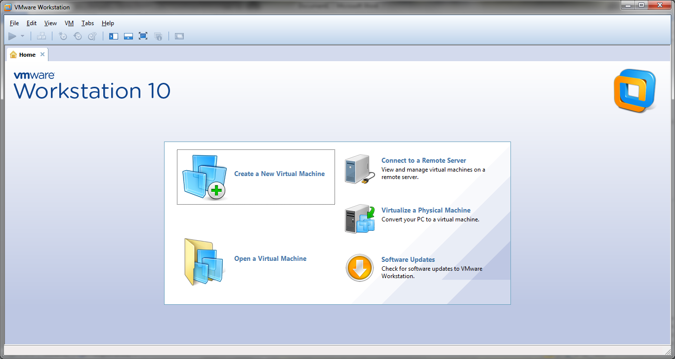

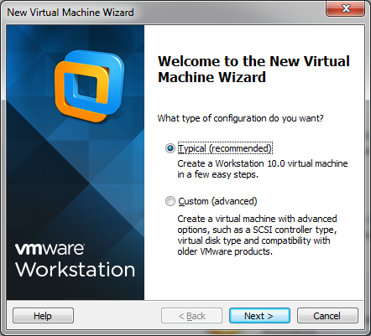

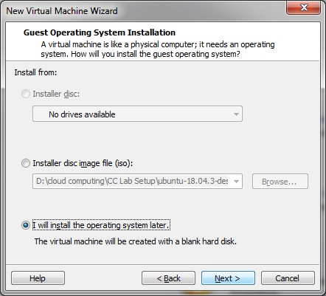

**Step :2 Name the virtual machine as vmware1**

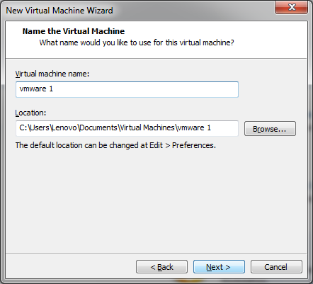

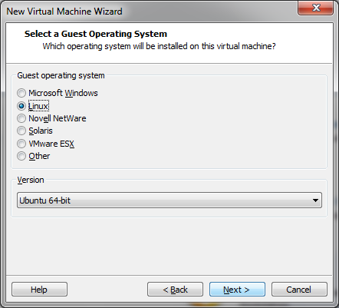

**Step:3 Give any specific disk size**

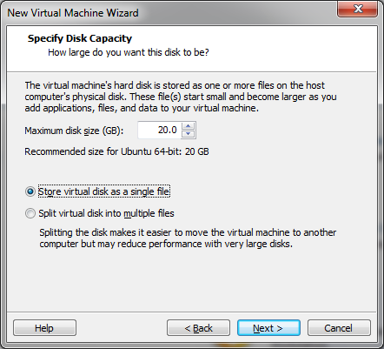

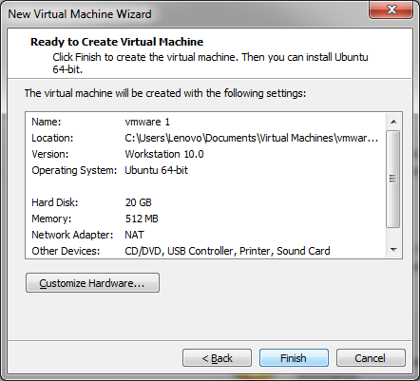

**Step 4: A virtual machine is created**

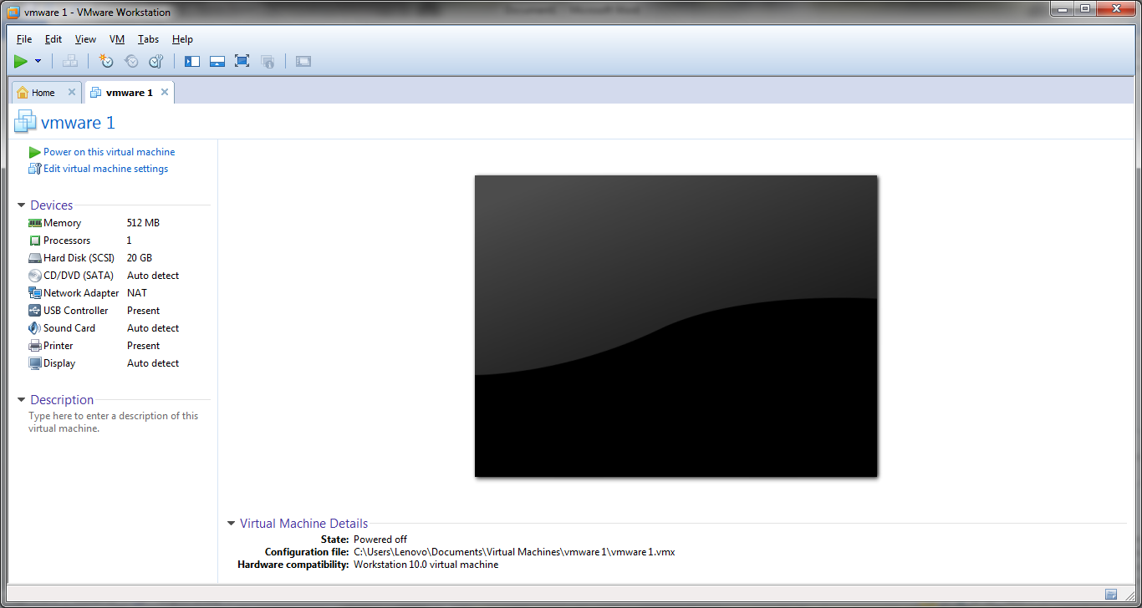

**Step 5: Now add new Hard Disk by the following steps**

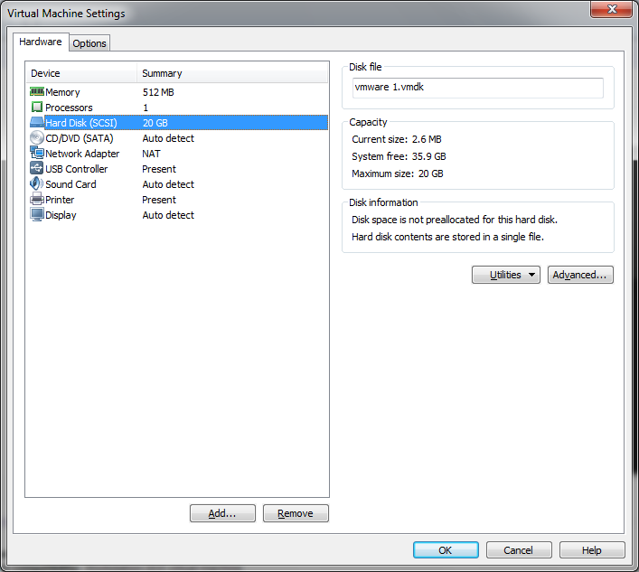

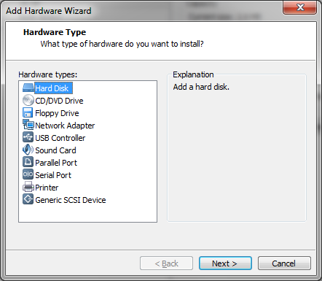

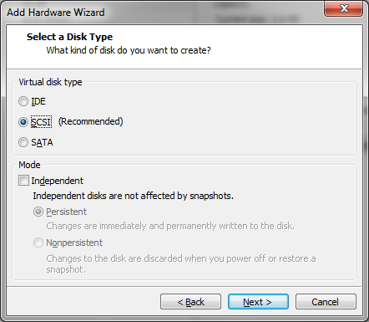

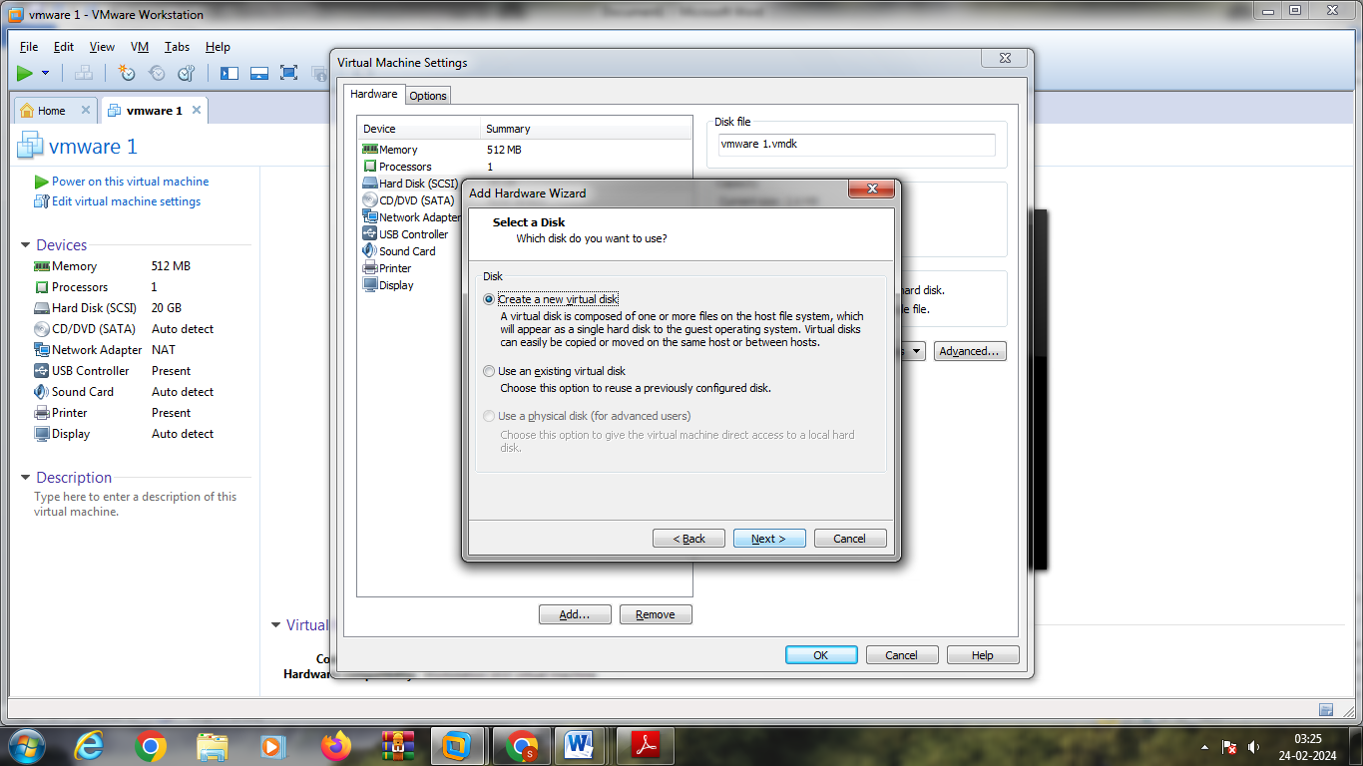

**Step 6:give the disk size for Hard Disk 2**

